***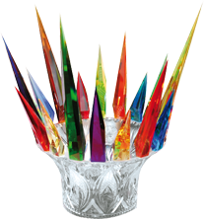 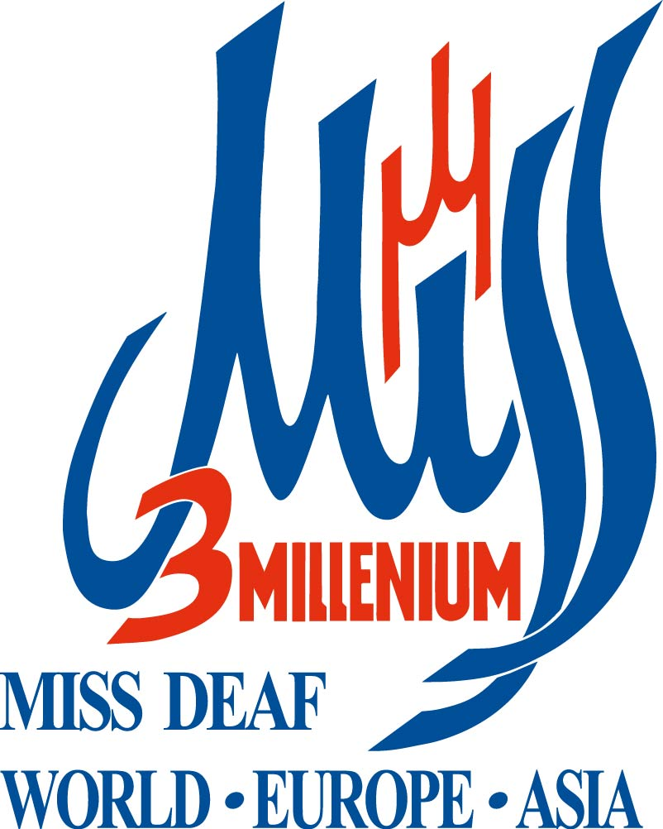 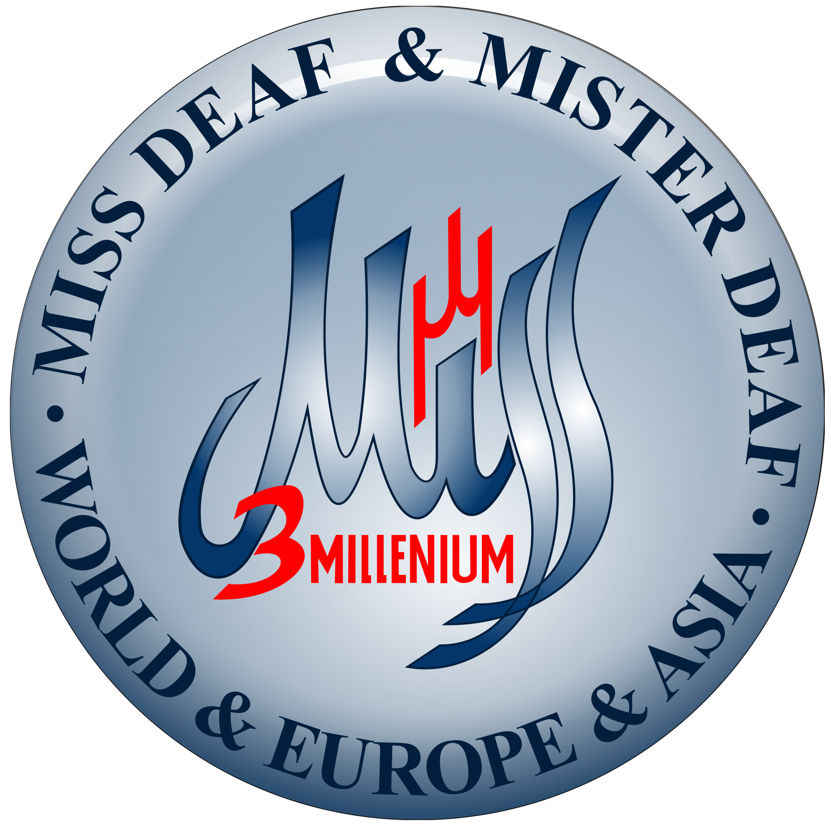***  ***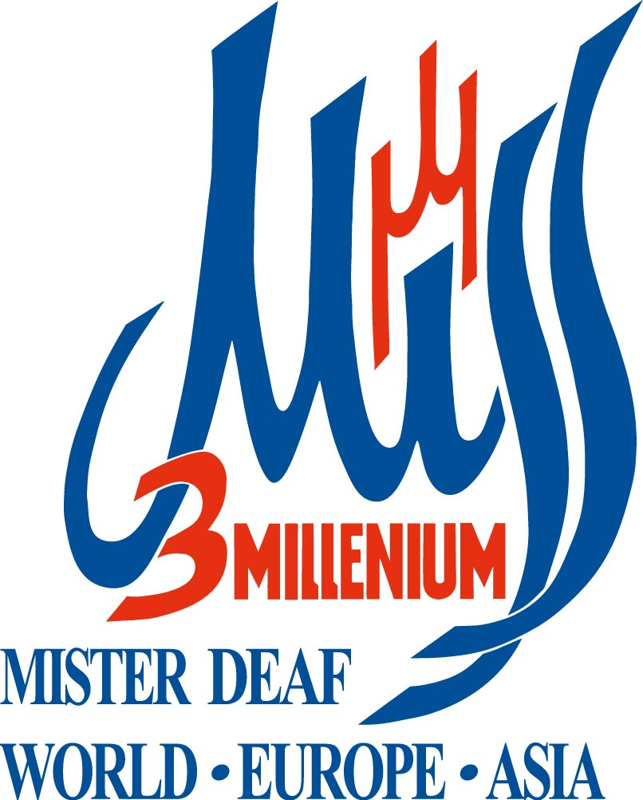*** ******

*Info for participant Miss and Mister Deaf World and Europe and Asia 2022*

*In Prague country Czech republic from 11.October 2022 to until 20.October 2022*

*And also three accompanying World Fashion show 2022*

*In Prague Czech republic from 11.October 2022 to until 20.October 2022*

*Where the will be showcase their fashion clothing the also all finalists of world contest*

*Miss & Mister Deaf World & Europe & Asia 2022 from around the world.*

***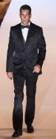C:\Users\mp\Desktop\Desktop\Desktop\Mongolia 2012 a vyřazené dívky 2012\Nová složka\2012_MACC_7704_Web.jpgC:\Users\mp\Desktop\Desktop\Desktop\DSC_4390.JPGC:\Users\mp\Desktop\Desktop\Desktop\2012_MACC_7678_Web.jpgC:\Users\mp\Desktop\Desktop\Desktop\2012_MACC_7650_Full.jpgC:\Users\mp\Desktop\Desktop\Desktop\2012_MACC_7614_Web.jpg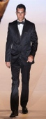C:\Users\mp\Desktop\Desktop\Desktop\DSC_4320.JPGC:\Users\mp\Desktop\Desktop\Desktop\2012_MACC_7662_Web.jpgC:\Users\mp\Desktop\Desktop\Desktop\2012_MACC_7658_Web.jpgC:\Users\mp\Desktop\Desktop\Desktop\Oblečení Míry barvy a Přihlášené státy 2010\Mongolia 2012 a vyřazené dívky 2012\2012_MACC_7624_Web.jpg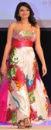C:\Users\mp\Desktop\Desktop\Desktop\2012_MACC_7632_Full.jpgC:\Users\mp\Desktop\Desktop\Desktop\2012_MACC_7670_Full.jpgC:\Users\mp\Desktop\Desktop\Desktop\DSC_5954.jpgC:\Users\mp\Desktop\Desktop\Desktop\DSC_5964.jpg***

*What things every contestant Miss and Mister Deaf must bring to Czech republic ?*

*Contestant Miss Deaf*

*1). one long evening dress and evening shoes ( for finals the contests Miss & Mister Deaf World*

*& Europe & Asia 2022 and one national costume of their country, on finals contests*

*Miss & Mister Deaf World & Europe & Asia 2022 and three World Fashion show 2022.*

*2) And one long dress and shoes (for fashion parade)*

*Clothes for your talent show and*

*your talent show*

*(* ***maximum time is******1,5 minute*** *= 90 seconds*

*Contestant Mister Deaf*

*1) one men´s black business suit, black shoes, white shirt and black butterfly*

*(for finals the contests Miss & Mister Deaf World & Europe & Asia 2022 )*

*2) one national costume of their country (for fashion parade)*

*3) one men´s business suit, shoes and shirt (for fashion parade)*

*Contestant Miss and Mister Deaf must have from their his country on three World Fashion*

*show 2022 and on the contests Miss & Mister Deaf World & Europe & Asia 2022*

*prescribed dress and national costume of their country.*

*Josef Uhlíř, president contest Miss & Mister Deaf World & Europe & Asia 2022 and three*

*accompanying World Fashion parades 2022 e-mail: josef@missdeafworld2011-2020.com*

*Sabína Dvulitová, contests manager Miss & Mister Deaf World & Europe & Asia 2022*

*and three accompanying World Fashion parades 2022 e-mail: sabina.mmdw@gmail.com*

*or skype: sabina.mmdw ( sign language )*

