THE WORLD COMPETITION
MISS - MISTER DEAF WORLD & EUROPE & ASIA 2025
From 14.July 2025 to until 24.July 2025 in Prague Czech republic
And accopanying fashionable WORLD FASHION SHOW
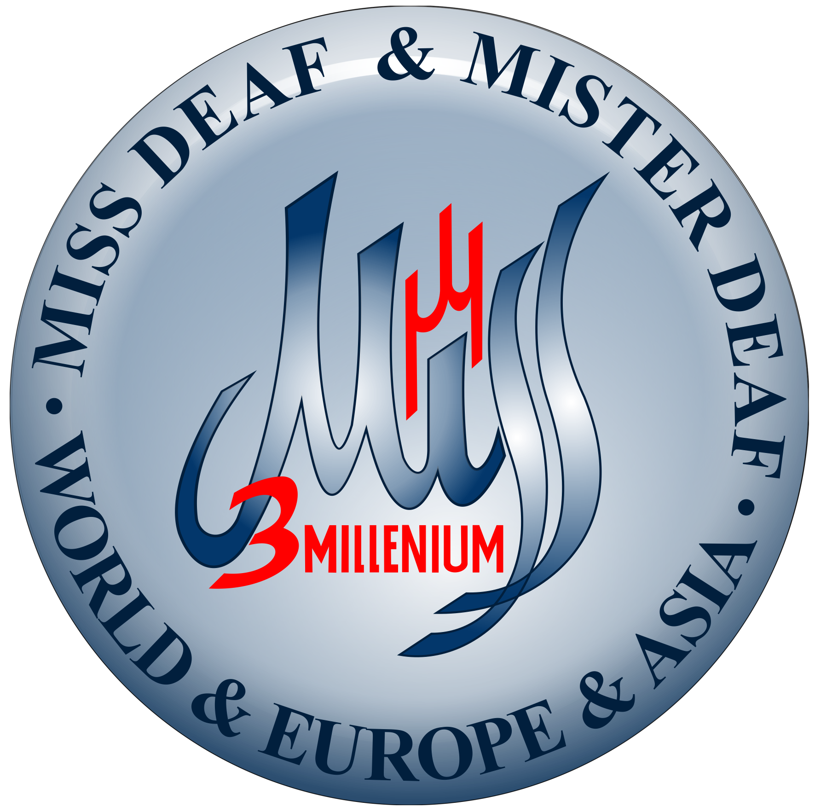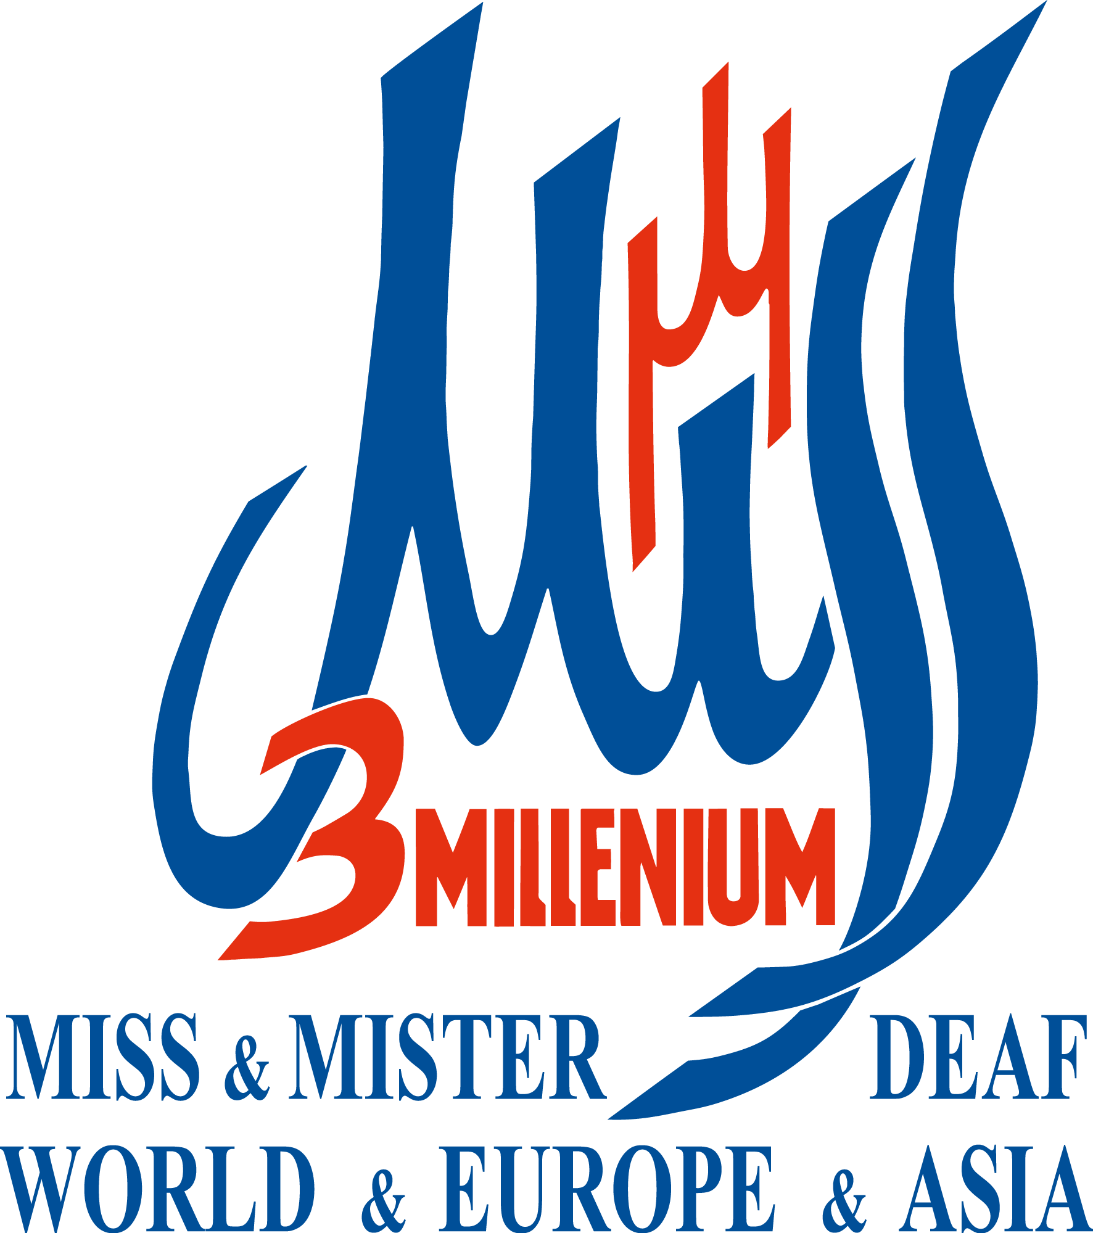
The binding application for the contest has to be sent on e-mail the organizer the competition at latest 20. May 2025
Including all prescribed photos and documents as well as a medical certificate about the extent hearing impairment.
E-mail: josef@missdeafworld2011-2020.com
Miss or Mister deaf and hard of hearing contestant
(Please write legibly on form)
Name: |  | Surname:
Age - Girl: - Boy: | Date of Birth: | Number of Passport /ID/
Address of residence Where You Live:
Country: |  | Girl: YES NO Boy: YES NO  Sign Language: Sign Language:
Email: Tel/Fax:
Arrival in Prague Czech Republic of day 14.July 2025 on airport Václava Havla and after competition with a flight back home on 24.July 2025.
Waist circumference (in cm): =  only girls fill  Waist circumference is measured at the  level of the navel  ,,,,,,,,,,,,,,,,,,,,,,,,,,,,,,,,,,,,,,,,,,,,,,,,,,,,,,,,,,,,,,,,,,  Hips circumference (in cm): =  only girls fill  Hips circumference, measured at the  widest of the point the buttocks  ,,,,,,,,,,,,,,,,,,,,,,,,,,,,,,,,,,,,,,,,,,,,,,,,,,,,,,,,,,,,,,,,,,  Chest circumference ( in cm): =  Fills both girl and boy |  | Height ( in cm): =  Fills both girl and boy  Bra size: =  Fills both only girls  Clothes size: =  Fills both girl and boy  Shoe size: =  Fills both girl and boy

1).Each registered winning Miss-Mister Deaf their country send together with the application on world competition the also at least four photos one photo the figure in swimsuit and portrait a face and figure in long social dress and photo figure in the national costume of their country and also medical certificate of hearing impairment and copies of a valid passport or I.D. Passport or I.D. must be valid still for at least 7 months after Arrival at the world contests.

2).In year 2024 from 14.July 2025 to 24.July 2025 the have all the winning Miss and Mister Deaf of their country
the stay the stay on world competition Miss-Mister Deaf World & Europe & Asia 2025 accommodation, food 3 times a day and non-alcoholic drinks in Prague Czech republic free.

3).By purchasing an air ticket with arrival on world competition Miss - Mister Deaf World & Europe & Asia 2024 in Prague Czech republic of the day 14 July 2025 and departure back home 24 July 2025, each contestant must send a copy of this air ticket on e -mail the organizer no later than 20 days before the start of the world competition.

4).After this set deadline for final sending of applications and all documents and four photos, copies passport or ID it will no longer be possible to apply for a stay free on the world competition Miss - Mister Deaf World & Europe & Asia 2025.

5).Day 20 May 2025 is the last day when all winning Miss and Mister Deaf 2025 of their country they can send on. The e-mail to organizer the world competition a legibly completed application form and all prescribed photos and medical certificate of hearing impairment and required written documents and copies of passport or I.D. Passport
or ID the must be valid at least another 7 months after arrival at world competition.

6). On finals the world competition,each Miss Deaf must prepare her own contestant discipline and which must not
be longer than 1.5 minutes (90 seconds) and also the appropriate and quality attire for this own contestant discipline.
If competing Miss Dean has an accompanying music for her discipline she must have it saved on Flash or DVD and must have one more backup DVD or Flash in case of damage.

7).If the competing girl has her own video projection and presentation about her country or town the video projection
must have good quality and must be on Flash or DVD. Contestant girls must have one backup copy video protection
or presentation in case of damage. Accompanying video projection must not be longer than 1.5 minutes (90seconds).

8).Contestant Miss Deaf must bring at least one long evening dress and suitable shoes which the girl will wear on the final evening and World Fashion show 2025 and also must have a high-quality national costume of their country

9).Each competing the Mister Deaf must bring a quality dark business suit white shirt with bow tie and quality black shoes and must also must have a high-quality national costume of their country.

10).Competition organizer will give free all contestantsMiss and Mister Deaf various same colorful clothes for casual
everyday during stay on world competition and contestants Miss and Mister Deaf can take these clothes home after
world competition as as contest prices.

11).Organizer also will give all contestant Miss - Mister Deaf swimsuit for finals world competition and contestants
swimsuit take home as contest prices. For the free time, must each contestant Miss and Mister Deaf shall bring their
own swimsuit to be able to take advantage of the pool.

12).In the year 2025 the total financial amount for accommodation and food and ticket on the final of the contests
and bus on the World Fashion show 2025 for the escorts is set at 825,- EURO or 895,- USD which must be paid by the escort in cash to the organizer immediately upon arrival on the world contests MMDW 2025 of day 14 July 2025 otherwise it will not be ensured on of the competition MMDW 2025 from 14.July 2025 to until 24.July 2025 for escorts everything as stated here.Each escort must also send on e-mail to the organizer copies of passport or I.D. and a legibly completed application no later than May 20, 2025.

13).After the final evening, only all finalists of the world competition and no one else will be showing their fashion clothes at the World Fashion show on the following days

14).With my own signature I declare that I understood all written instructions in application for of world competition
Miss and Mister Deaf World & Europe & Asia 2025 and World Fashion show 2025

Signature ---------------------------- Date: ---------------------------------

From year 2025 new Ms. Miroslava Masaříková the organizer and of the CEO annual world competition
Miss – MISTER DEAF WORLD & EUROPE & ASIA 2025 and accompanying fashionable WORLD FASHION SHOW 2025 E-mail: josef@missdeafworld2011-2020.com Website for world competition www: missdeafworld2011-2020.com
Facebook the world contests new organizer Miroslava Masaříková https://www.facebook.com/josef.uhlir.missdeaf/

Founder and honorary president of the world cmpetition Miss-Mister Deaf World Europe Asia 2025 Mr.Josef Uhlíř
Facebook the world contests MMDW Mr.Josef Uhlíř https://www.facebook.com/profile.php?id=100090218169156

